Hands-on :
Spring REST using Spring Boot 3 :
REST - Country Web Service

File name : Country.java
package com.cognizant.springlearn;

public class Country {

private String code;
private String name;

public Country() {
}

public Country(String code, String name) {
this.code = code;
this.name = name;
}

public String getCode() {
return code;
}

public void setCode(String code) {
this.code = code;
}

public String getName() {
return name;
}

public void setName(String name) {
this.name = name;
}
}

File name : country.xml
<?xml version="1.0" encoding="UTF-8"?>

<beans xmlns="http://www.springframework.org/schema/beans"
xmlns:xsi="http://www.w3.org/2001/XMLSchema-instance"
xsi:schemaLocation="
http://www.springframework.org/schema/beans
https://www.springframework.org/schema/beans/spring-beans.xsd">

<bean id="country"
class="com.cognizant.springlearn.Country">

<property name="code" value="IN"/>
<property name="name" value="India"/>

</bean>

</beans>

File name : CountryController.java
package com.cognizant.springlearn.controller;

import org.springframework.context.support.ClassPathXmlApplicationContext;
import org.springframework.web.bind.annotation.RequestMapping;
import org.springframework.web.bind.annotation.RestController;

import com.cognizant.springlearn.Country;

@RestController
public class CountryController {

@RequestMapping("/country")
public Country getCountryIndia() {

ClassPathXmlApplicationContext context =
new ClassPathXmlApplicationContext("country.xml");

Country country = context.getBean("country", Country.class);

context.close();
return country;
}
}

Console Output :
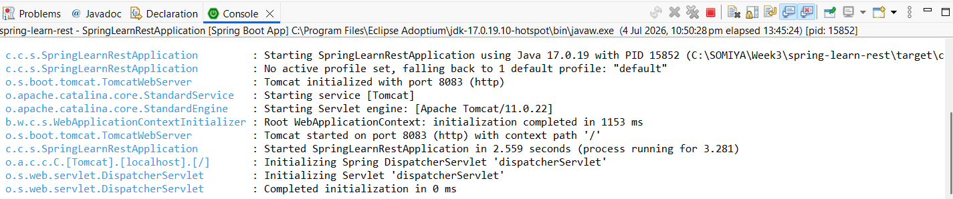

Browser Output :
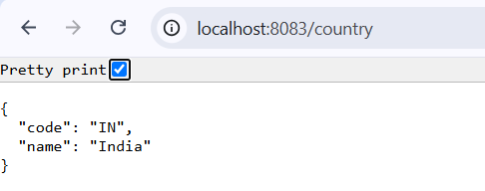

Http Headers :
